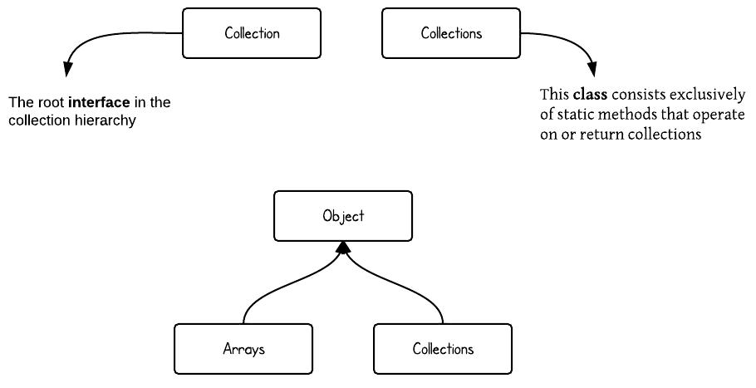**1. Collection vs Collections**

First of all, "Collection" and "Collections" are two different concepts. As you will see from the hierarchy diagram below, "Collection" is a root interface in the Collection hierarchy but "Collections" is a class which provide static methods to manipulate on some Collection types.

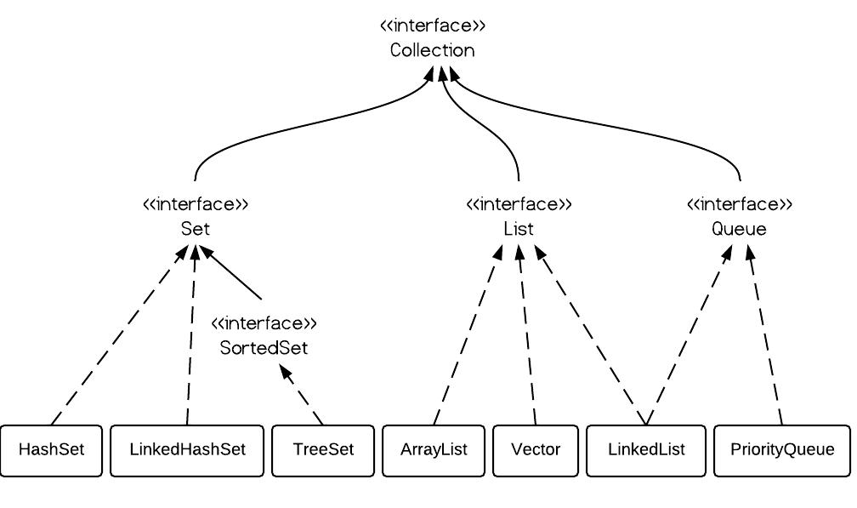**2. Class hierarchy of Collection**

The following diagram demonstrates class hierarchy of Collection.

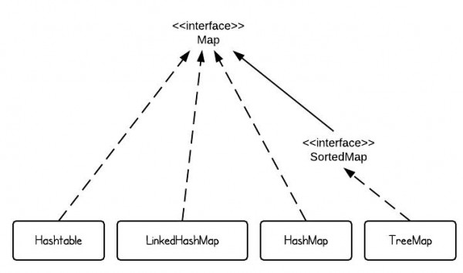

**3. Class hierarchy of Map**

Here is class hierarchy of Map.

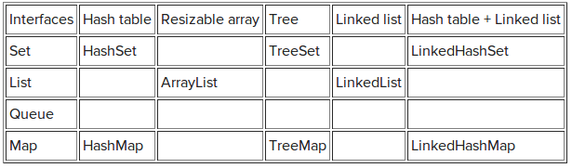**4. Summary of classes**

